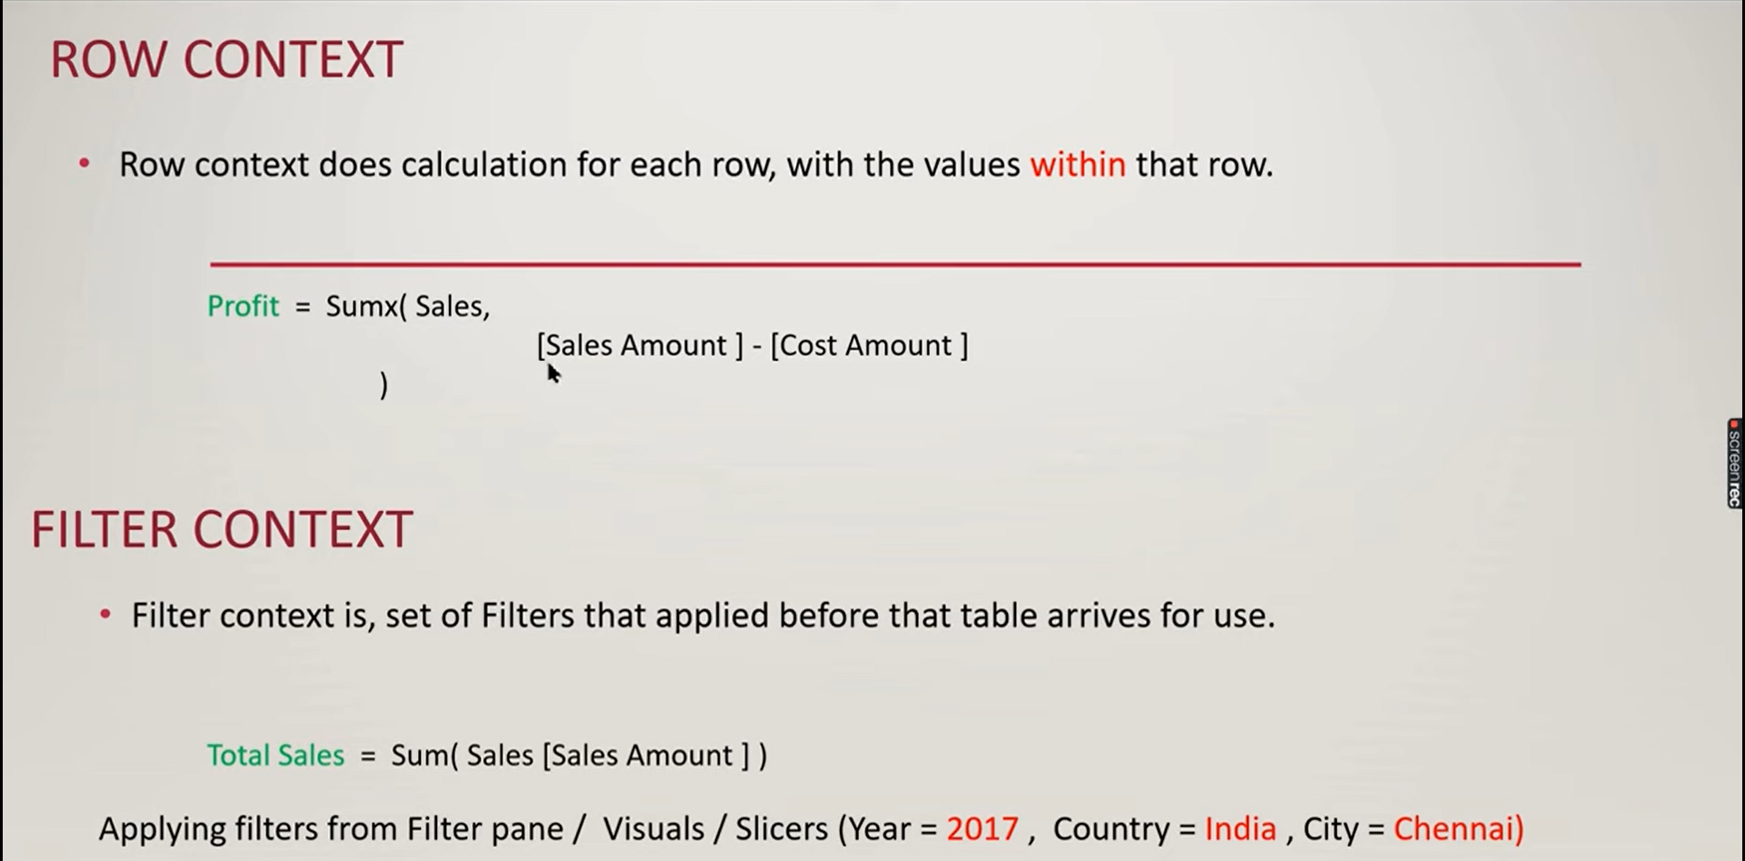



Dax Formatter.

Conquest Customers =CALCULATE (DISTINCTCOUNT ( 'Table'[Customer] ),FILTER (ALLSELECTED ( 'Table'[Customer] ),[**FYTD Measure**] >= 500 && [**PFYTD MEASURE**] =))